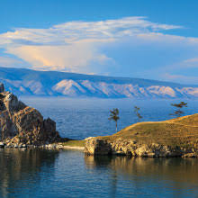**The Colossus Of Rhodes**

Machu Picchu is an ancient Incan citadel perched high in the Andes Mountains, renowned for its breathtaking architecture and panoramic views.

**History**

Zeus, the chief deity in ancient Greek mythology, was the ruler of Mount Olympus and the god of the sky, lightning, and thunder, playing a central role in Greek religion and mythology.